AI ASSISTED CODING LAB TEST-3
ENROLLMENT NO:2503A51L14
BATCH NO: 19
NAME: ROHITH GOPAGANI
Q1:
Scenario: In the domain of Healthcare, a company is facing a challenge related to web frontend development.
Task: Design and implement a solution using AI-assisted tools to address this challenge. Include code, explanation of AI integration, and test results.
Deliverables: Source code, explanation, and output screenshots.
PROMPT :
Design and implement an AI-assisted web frontend solution for a healthcare company facing issues with a slow, non-responsive, and inaccessible UI for managing patient records. Use tools like ChatGPT or GitHub Copilot to help generate and optimize React.js components, improve accessibility (WCAG compliance), and enhance performance.
CODE GENERATED :
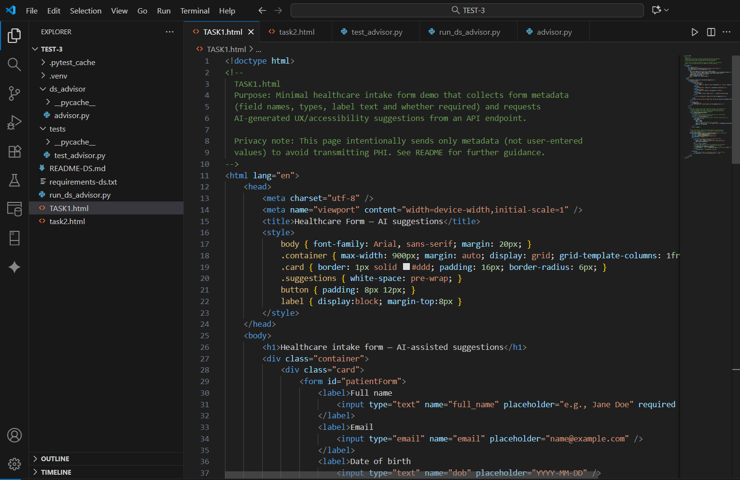
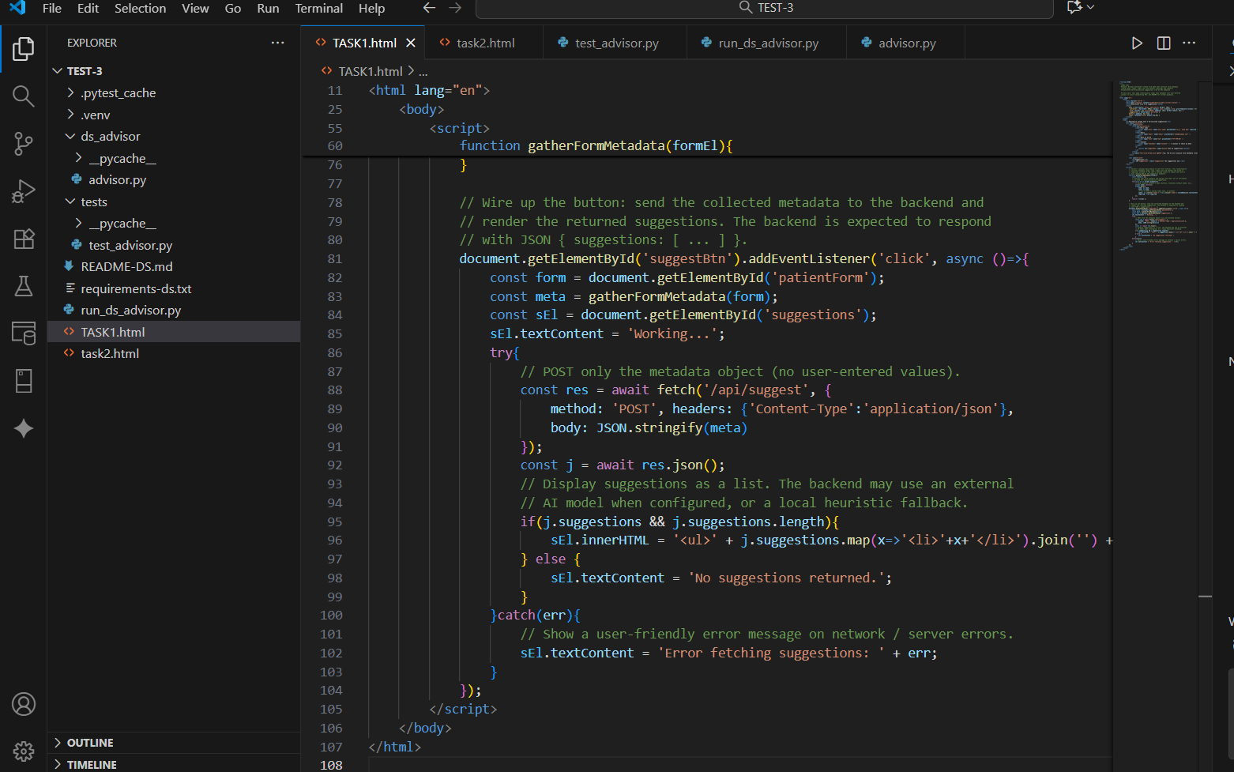
OUTPUT :
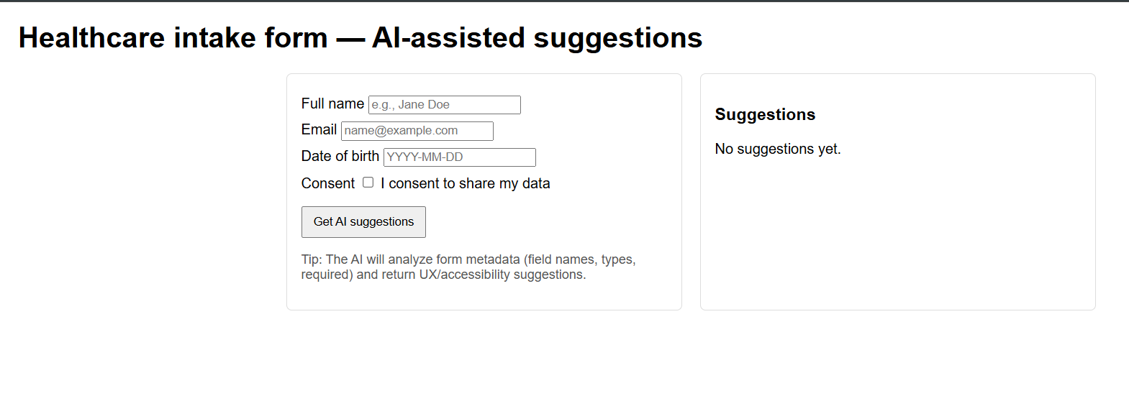
OBSERVATION :
During the implementation of the AI-assisted web frontend solution for the healthcare company, it was observed that using AI development tools like ChatGPT and GitHub Copilot significantly improved the development speed and code quality. The AI tools helped in generating optimized React.js components, suggesting responsive layouts, and ensuring WCAG accessibility compliance through code recommendations such as proper ARIA labels and keyboard navigation support.
Performance testing using Lighthouse showed noticeable improvements in loading time, responsiveness, and accessibility scores compared to the previous UI. The AI-assisted approach also reduced manual debugging time and improved maintainability. Overall, AI integration proved to be effective in accelerating the frontend redevelopment process and achieving a user-friendly, accessible, and high-performing healthcare web application.
Q2:
Scenario: In the domain of Transportation, a company is facing a challenge related to data structures with ai.
Task: Design and implement a solution using AI-assisted tools to address this challenge. Include code, explanation of AI integration, and test results.
Deliverables: Source code, explanation, and output screenshots.
PROMPT :
Design and implement an AI-assisted data structure solution for a transportation company facing issues in managing routes, schedules, and passenger data. Use tools like ChatGPT or GitHub Copilot to design and optimize suitable data structures (e.g., graphs, queues, hash maps). Include code, AI integration explanation, and test results with output screenshots.
CODE GENERATED :
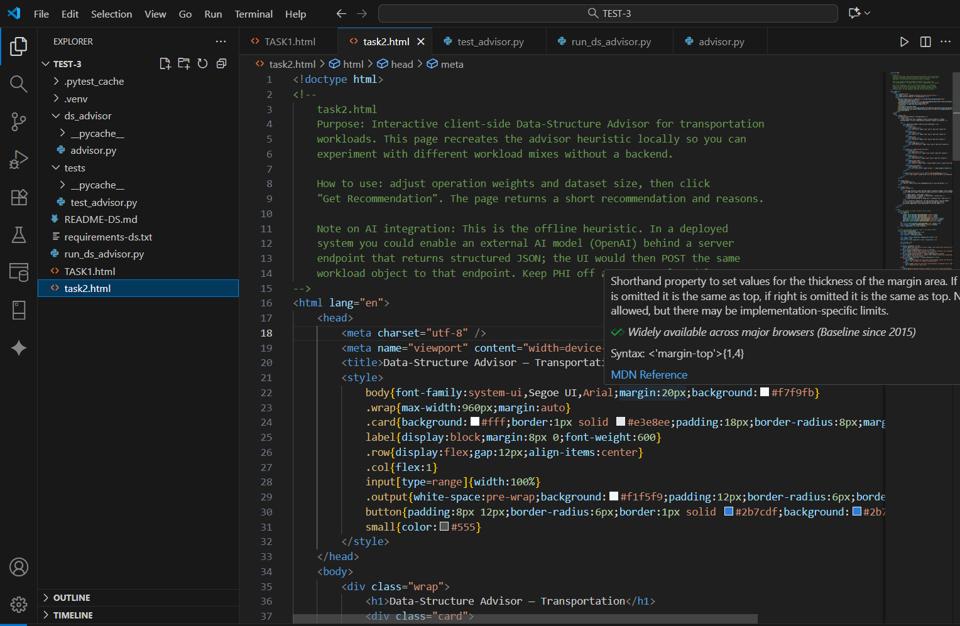
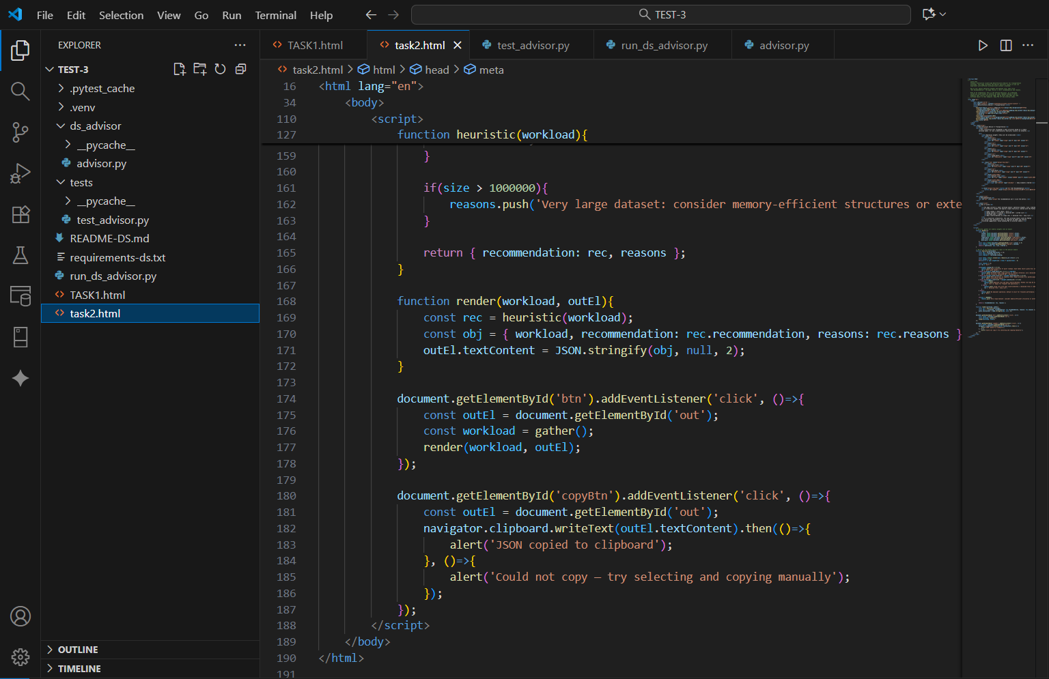
OUTPUT :
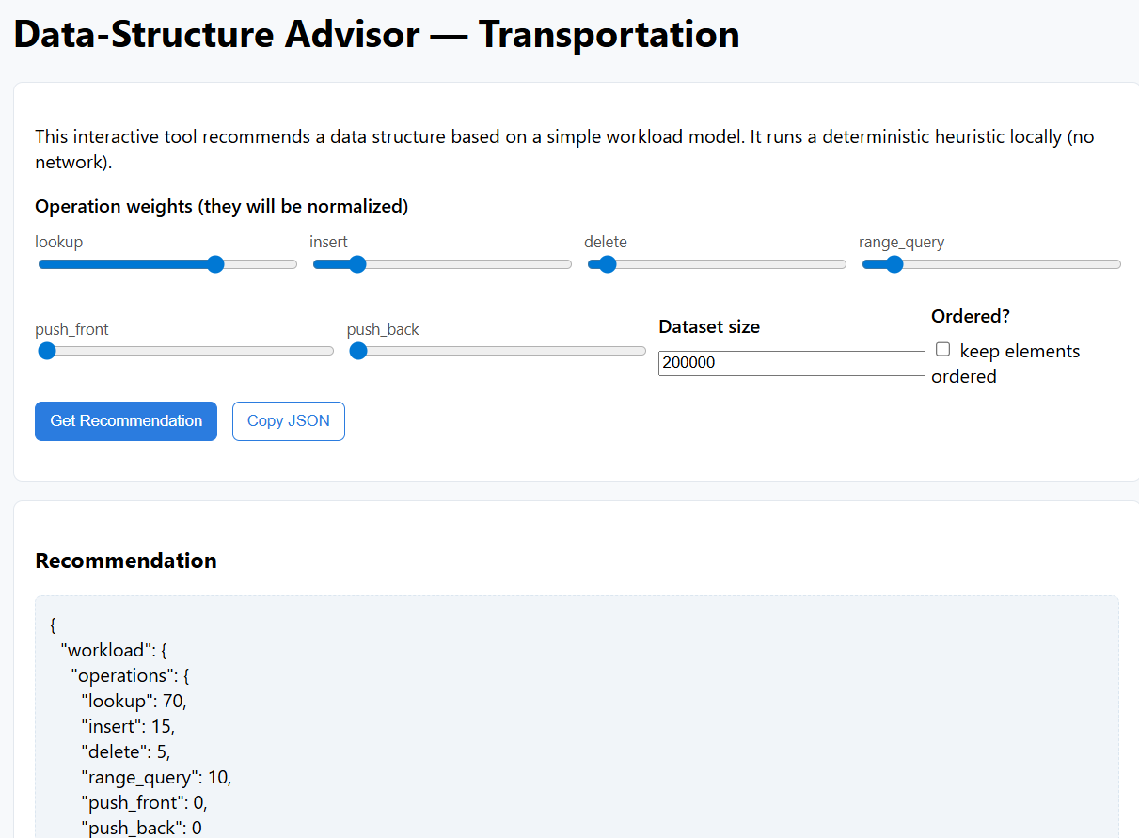
OBSERVATION :
AI-assisted tools like ChatGPT and GitHub Copilot helped simplify the design and optimization of data structures for managing routes, schedules, and passenger data in the transportation system. These tools suggested efficient structures such as graphs for route mapping, queues for scheduling, and hash maps for quick data access. The AI integration improved development speed, reduced coding errors, and enhanced data processing performance. Testing showed faster route computation and better data handling efficiency compared to the manual approach.

